**Answers to the Study Plan Problems and Applications**

Use the following information to work Problems 1 to 2.

Sara’s income is $12 a week. The price of popcorn is $3 a bag, and the price of a smoothie is $3.

1. Calculate Sara’s real income in terms of smoothies. Calculate her real income in terms of popcorn. What is the relative price of smoothies in terms of popcorn? What is the opportunity cost of a smoothie?

Sara’s real income is 4 smoothies. Sara’s real income in terms of smoothies is equal to her money income divided by the price of a smoothie. Sara’s money income is $12, and the price of a smoothie is $3. Sara’s real income is $12 divided by $3 a smoothie, which is 4 smoothies.

Sara’s real income is 4 bags of popcorn. Sara’s real income in terms of popcorn is equal to her money income divided by the price of a bag of popcorn, which is $12 divided by $3 a bag or 4 bags of popcorn.

The relative price of a smoothie is 1 bag of popcorn per smoothie. The relative price of a smoothie is the price of a smoothie divided by the price of a bag of popcorn. The price of a smoothie is $3 and the price of popcorn is $3 a bag, so the relative price of a smoothie is $3 divided by $3 a bag, which equals 1 bag of popcorn per smoothie.

The opportunity cost of a smoothie is 1 bag of popcorn. The opportunity cost of a smoothie is the quantity of popcorn that must be forgone to get a smoothie. The price of a smoothie is $3 and the price of popcorn is $3 a bag, so to buy one smoothie Sara must forgo 1 bag of popcorn.

2. Calculate the equation for Sara’s budget line (with bags of popcorn on the left side). Draw a graph of Sara’s budget line with the quantity of smoothies on the *x*-axis. What is the slope of Sara’s budget line? What determines its value?

The equation that describes Sara’s budget line is *Q*P = 4 – *Q*S. Call the price of popcorn *P*P and the quantity of popcorn *Q*P, the price of a smoothie *P*S and the quantity of smoothies *Q*S, and income *y*. Sara’s budget equation is *P*P*Q*P + *P*S*Q*S = *y*. If we substitute $3 for the price of popcorn, $3 for the price of a smoothie, and $12 for the income, the budget equation becomes $3*Q*P + $3*Q*S = $12. Dividing both sides by $3 and subtracting *Q*S from both sides gives *Q*P = 4 – *Q*S.

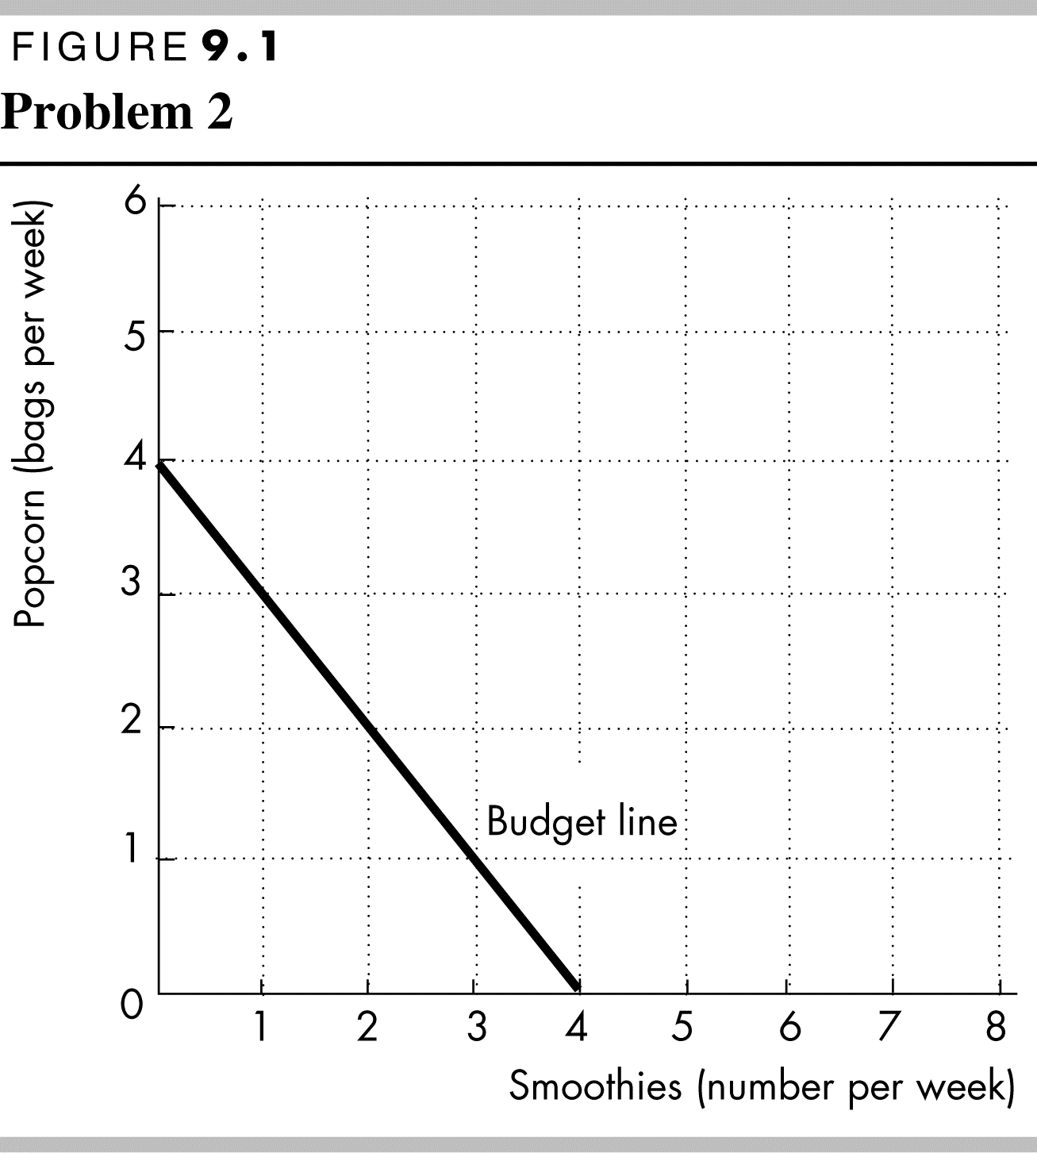To draw a graph of the budget line, plot the quantity of smoothies on the *x*-axis and the quantity of popcorn on the *y*-axis. The budget line is a straight line from 4 bags of popcorn on the *y*-axis to 4 smoothies on the *x*-axis.

The slope of the budget line, when smoothies are plotted on the *x*-axis, is minus 1. The magnitude of the slope is equal to the relative price of a smoothie. The slope of the budget line is “rise over run.” If the quantity of smoothies decreases from 4 to 0, the quantity of popcorn increases from 0 to 4. The rise is 4 and the run is 4. Therefore, the slope equals 4/4, which is 1.

Use the following data to work Problems 3 and 4.

Sara’s income falls from $12 to $9 a week, while the price of popcorn is unchanged at $3 a bag and the price of a smoothie is unchanged at $3.

3. What is the effect of the fall in Sara’s income on her real income in terms of (a) smoothies and (b) popcorn?

a. Sara’s real income falls from 4 smoothies to 3 smoothies. Sara’s real income in terms of smoothies is equal to her money income divided by the price of a smoothie. Sara’s money income is now $9 and the price of a smoothie is $3. Sara’s real income is now $9 divided by $3 a smoothie, which is 3 smoothies.

b. Sara’s real income falls from 4 bags of popcorn to 3 bags of popcorn. Sara’s real income in terms of popcorn is equal to her money income divided by the price of a bag of popcorn. Sara’s money income is now $9 and the price of a bag of popcorn is $3. Sara’s real income is now $9 divided by $3 a bag, which is 3 bags of popcorn.

4. What is the effect of the fall in Sara’s income on the relative price of a smoothie in terms of popcorn? What is the slope of Sara’s new budget line if it is drawn with smoothies on the *x*-axis?

The relative price of a smoothie is 1 bag of popcorn per smoothie, the same relative price as before her income fell. The relative price does not depend on Sara’s income. Instead the relative price of a smoothie is the price of a smoothie divided by the price of a bag of popcorn. The price of a smoothie is $3 and the price of popcorn is $3 a bag, so the relative price of a smoothie is $3 divided by $3 a bag. The relative price equals 1 bag per smoothie.

The slope of the budget line, when smoothies are plotted on the *x*-axis is minus 1, the same slope as before her fall in income. The magnitude of the slope of the budget line is equal to the relative price of a smoothie. The relative price does not change when Sara’s income decreases so the slope of the budget line does not change.

5. Sara’s income is $12 a week. The price of popcorn rises from $3 to $6 a bag, and the price of a smoothie is unchanged at $3. Explain how Sara’s budget line changes with smoothies on the *x*-axis.

The budget line rotates inward around the unchanged *x* intercept. The magnitude of the slope of the budget line is equal to the relative price of a smoothie. The relative price of a smoothie is the price of a smoothie divided by the price of a bag of popcorn. The rise in the price of a bag of popcorn lowers the relative price of a smoothie in terms of popcorn. The relative price has fallen so the magnitude of the slope of the budget line has fallen.

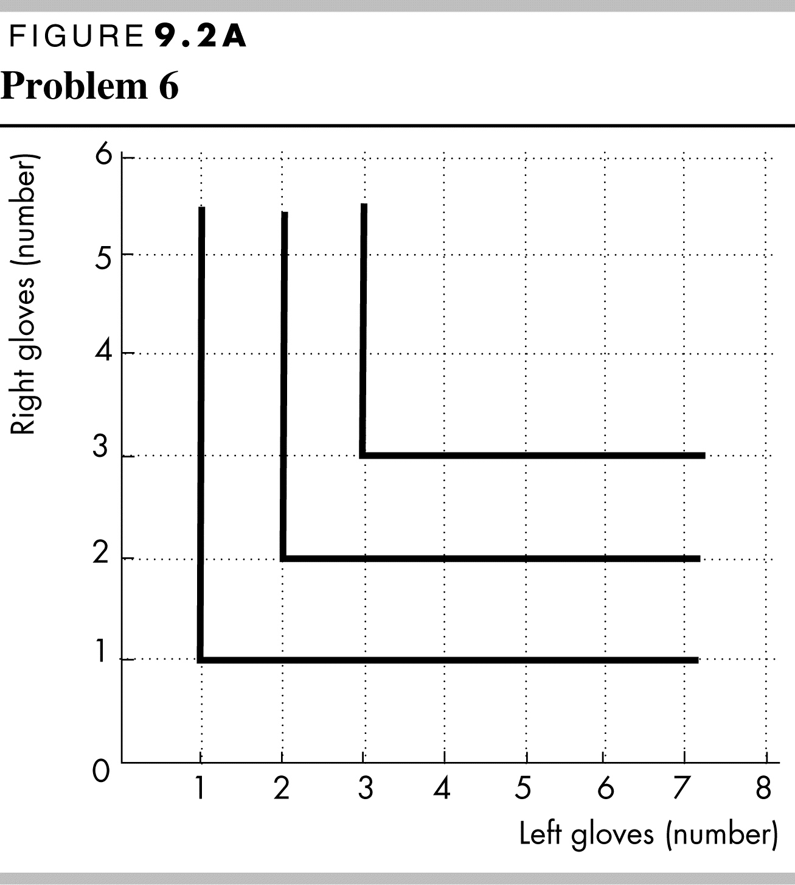6. Draw figures that show your indifference curves for the following pairs of goods. For each pair, are the goods perfect substitutes, perfect complements, substitutes, complements, or unrelated goods?

* Right gloves and left gloves

Figure 9.2A is to the right. Right gloves/left gloves are perfect complements. Because these are perfect complements, the indifference curves are right angles.

* 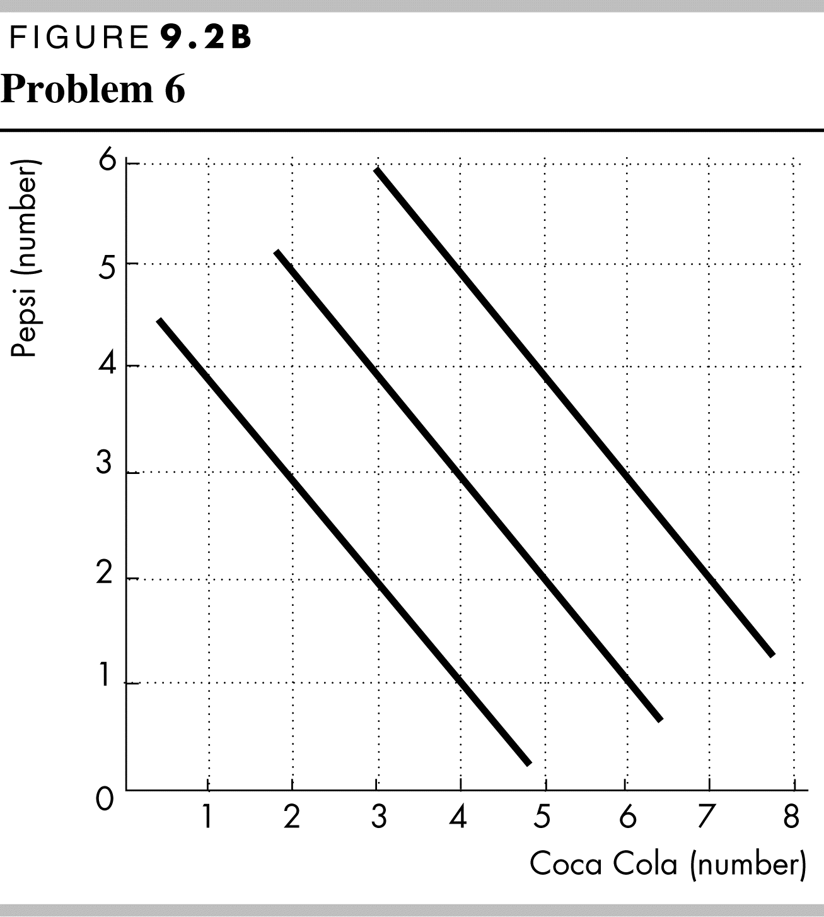Coca-Cola and Pepsi

Figure 9.2B is to the right. These are, for most students, almost perfect substitutes. The indifference curves should either be linear (for perfect substitutes, as shown in Figure 9.2B) or nearly linear.

* 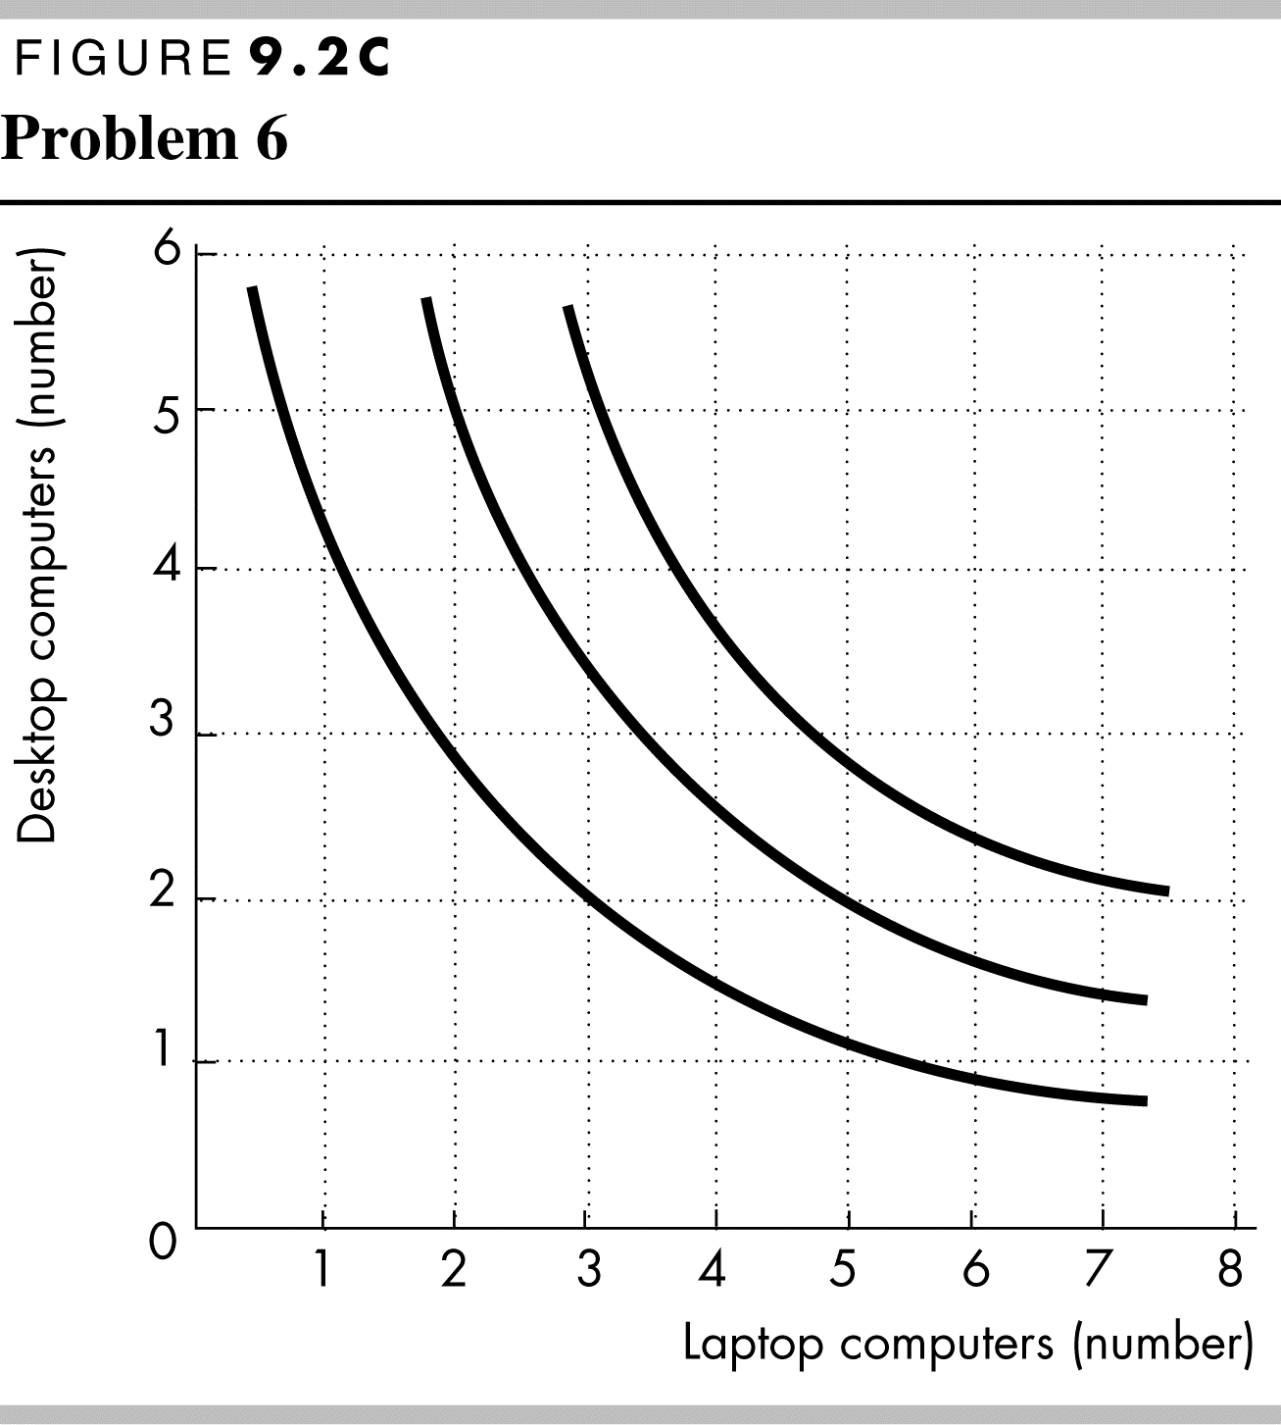Desktop computers and laptop computers

Figure 9.2C is to the right. These are substitutes, though not perfect substitutes. The indifference curves are bowed inward toward the origin.

* 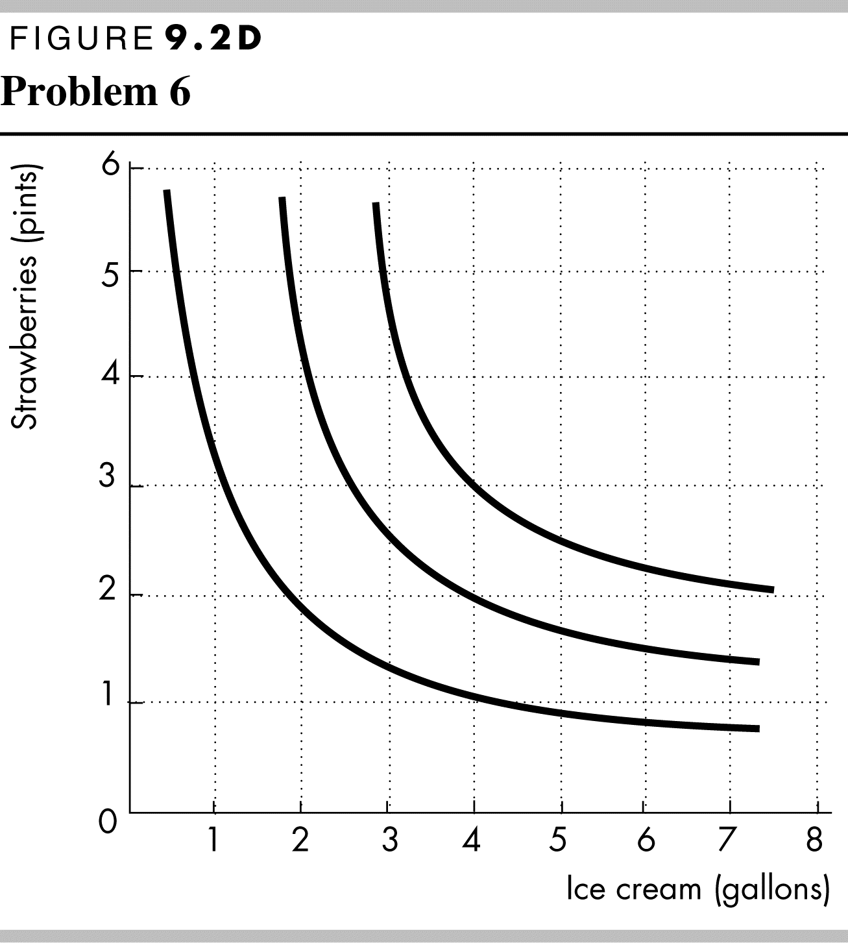Strawberries and ice cream

Figure 9.2D is to the right. These are probably complements for many students, though not perfect complements. The indifference curves are not right angles, as they would be for perfect complements, but instead are bowed inward toward the origin.

7. Discuss the shape of the indifference curve for each of the following pairs of goods:

* Sugar and honey

Sugar and honey are substitutes. They are not perfect substitutes, so the indifference curves are bowed in towards the origin. The marginal rate of substitution falls, moving down along an indifference curve.

* Movies and popcorn

These are complements but not perfect complements. The indifference curves should be significantly bowed inward. The marginal rate of substitution falls rapidly, moving down along an indifference curve.

* Printers and printer cartridges

These are perfect complements, so the indifference curves are right angles. The marginal rate of substitution does not change moving down along the indifference curve. It changes only when moving around the 90-degree point, where it goes from infinity to zero.

* Snoods and scarves

These are nearly perfect—if not perfect—substitutes. The indifference curves should be either nearly linear or linear. If the indifference curves are nearly linear, then the marginal rate of substitution falls slightly, moving down along an indifference curve; if the indifference curves are linear, then the marginal rate of substitution does not change, moving down along the indifference curve.

Explain the relationship between the shape of the indifference curve and the marginal rate of substitution as the quantities of the two goods change.

Use the following data to work Problems 8 and 9.

Pam has made her best affordable choice of cookies and granola bars. She spends all of her weekly income on 30 cookies at $1 each and 5 granola bars at $2 each. Next week, she expects the price of a cookie to fall to 50¢ and the price of a granola bar to rise to $5.

8. a. Will Pam be able to buy and want to buy 30 cookies and 5 granola bars next week?

Pam can still buy 30 cookies and 5 granola bars. When Pam buys 30 cookies at $1 each and 5 granola bars at $2 each, she spends $40 a week. Now that the price of a cookie is 50 cents and the price of a granola bar is $5, 30 cookies and 5 granola bars will cost $40. So Pam can still buy 30 cookies and 5 granola bars. But Pam will not *want* to buy 30 cookies and 5 granola bars because the marginal rate of substitution does not equal the relative price of the goods. Pam will move to a point on the highest indifference curve possible where the marginal rate of substitution equals the relative price.

b. Which situation does Pam prefer: cookies at $1 and granola bars at $2 or cookies at 50¢ and granola bars at $5?

Pam prefers cookies at 50 cents each and granola bars at $5 each because she can get onto a higher indifference curve than when cookies are $1 each and granola bars are $2 each. To see why Pam can move to a higher indifference curve, note that the new budget line and the old budget line both pass through the point 30 cookies and 5 granola bars. If granola bars are plotted on the *x*-axis, the marginal rate of substitution at this point on Pam’s indifference curve is equal to the relative price of a granola bar at the original prices, which is 2. The new relative price of a granola bar is $5/50 cents, which is 10. That is, the budget line is steeper than the indifference curve at 30 cookies and 5 granola bars. Pam’s new equilibrium combination of cookies and granola bars must be on an indifference curve at a point steeper than the initial indifference curve. Because the new budget line is steeper and passes through the initial equilibrium combination, the new best affordable point must lie above the initial equilibrium point so it must be on a higher indifference curve.

9. a. If Pam changes how she spends her weekly income, will she buy more or fewer cookies and more or fewer granola bars?

Pam will buy more cookies and fewer granola bars. The new budget line and the old budget line pass through the point at 30 cookies and 5 granola bars. If granola bars are plotted on the *x*-axis, the marginal rate of substitution at this point on Pam’s indifference curve is equal to the relative price of a granola bar at the original prices, which is 2. The new relative price of a granola bar is $5/50 cents, which is 10. That is, the budget line is steeper than the indifference curve at 30 cookies and 5 granola bars. Pam will buy more cookies and fewer granola bars.

b. When the prices change next week, will there be an income effect, a substitution effect, or both at work?

There will be a substitution effect and an income effect. A substitution effect arises when the relative price changes and the consumer moves along the *same* indifference curve to a new point where the marginal rate of substitution equals the new relative price. An income effect arises when the consumer moves from one indifference curve to another, keeping the relative price constant.

Use the following information to work Problems 10 and 11.

**Second-Hand Clothing Is More Popular Than Ever. Even in a Pandemic**

Resale has been doing very well through the pandemic. At Poshmark, which connects buyers with sellers of new and used merchandise, sales are up 50% year-over-year from mid-April into May.

Source: cnn.com, June 12, 2020

10. a. According to the news clip, is second-hand clothing a normal good or an inferior good? If the price of second-hand clothing falls and income remains the same, explain how the quantity of second-hand clothing bought changes.

According to the article, the demand for second-hand clothing increased when the economy was in the pandemic and incomes fell. Because the demand increased when income decreased, second-hand clothing is an inferior good.

If the price of second-hand clothing falls and income remains the same, the quantity of second-hand clothing purchased increases as long as the substitution effect is larger than the income effect.

b. Describe the substitution effect and the income effect that occur.

The price fall creates both a substitution effect and an income effect. The substitution effect leads to an increase in the quantity of second-hand clothing demanded. The price decrease increases consumers’ real incomes. Because used clothing is an inferior good, the income effect leads to a decrease in the quantity of vintage clothing purchased.

11. Draw a graph of a person’s indifference curves for second-hand clothing and other goods. Then draw two budget lines to show the effect of a fall in income on the quantity of second-hand clothing purchased.

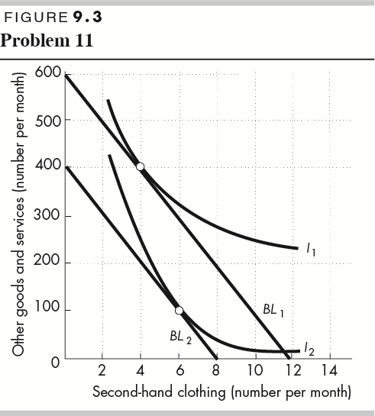In Figure 9.3, the fall in income shifts the budget line from *BL*1 to *BL*2. The quantity of second-hand clothing purchased increases, in the figure from 4 items per month to 6 items per month.